Noida Institute Of Engineering & Technology

Greater Noida

Project Synopsis

For

Sentiment Analysis

Session (2022-2023)

# DEPARTMENT INFORMATION TECHNOLOGY

Course Name :- B-Tech

**Submitted By :-**

Suarj kumar(2001330130168)

Pranav Anand(2001330130113)

Saket kumar(2001330130135)

**Submitted To :**

1. TITLE :

Sentiment Analysis on Audio

1. INTRODUCTION :

This tool is based on data analysis and processing. The first step in implementing a machine learning algorithm is to understand the right learning experience from which the model starts improving on. Data pre-processing plays a major role when it comes to machine learning. In order to make the model more efficient we need lots of data, so we turned our focus primarily on one of the largescale data producers owned by Facebook which is nothing but WhatsApp. WhatsApp claims that nearly 55 billion messages are sent each day. The average user spends 195 minutes per week on WhatsApp, and is a member of plenty of groups. With this treasure house of data right under our very noses, it is but imperative that we embark on a mission to gain insights on the messages which our phones are forced to bear witness to.

1. OBJECTIVE :

In this decade the upcoming technologies are mainly dependent on data. This data can only be obtained if there is some research applied on the context of the requirements of the tool. Since a lot of machine learning enthusiasts develop models which helps solve multiple problems the requirements of appropriate data are very large scale this project aims to provide a better understanding towards various types of chats. This analysis proves to be better input to machine learning models which essentially explore the chat data. These models require proper learning instances which provides better accuracy for these models. Our project ensures to provide an in-depth exploratory data analysis on various types of WhatsApp chats



1. PROBLEM STATEMENT :

WhatsApp-Analyzer is a statistical analysis tool for WhatsApp chats. Working on the chat files that can be exported from WhatsApp it generates various plots showing, for example, which another participant a user responds to the most. We propose to employ dataset manipulation techniques to have a better understanding of WhatsApp chat present in our phones.

1. EXISTING SYSTEM :

There is a lot of development in the current system. In the older version there was no feature to display status, there was no feature to share documents and there was no feature to share location. In the current version, all of these

features are available. In older version we couldnt share images through docs format. In this system user is able to access WhatsApp in windows through WhatsApp web application, which can be connected through QR code. There is another feature called export chat where user can send or share or get the chat detail for data analysis through email, Facebook or some messenger application.

1. PROPOSED SYSTEM :

Data pre-processing, the initial part of the project is to understand implementation and usage of various python- built modules. The above process helps us to understand why different modules are helpful rather than implementing those functions from scratch by the developer. These various modules provide better code representation and user understandability. The following libraries are used such as numpy, scipy pandas, csv, sklearn, matplotlib, sys, re, emoji, nltk seaborn etc.

Exploratory data analysis, first step in this to apply a sentiment analysis algorithm which provides positives and negative part of the chat and is used to plot Bar Graph based on these parameters.

7 . LITERATURE SURVEY :

This helped us in knowing which module is best suited for sentimental analysis and how each of them can alter the results obtained[1]. With this type of the development in the sentiment analysis domain, a system which can extract the information in terms of the emotions of the people regarding a specific product from any of the three mediums (text, audio or video) can lead to the better technological aspects in the market. The objective was to build a system which can identify the sentiment categorized into six types: anger, joy, disgust, sadness, fear, and surprise of a video when the data is fed into it. The system developed depicts how much of each of these sentiments are present in a particular input.

Audio & Video Sentimental Analysis using Automatic speech Recognition and scenario and behaviour detection is an emerging Research area where opinion shown by an entity is explored from natural audio and video. [2]: There has been some exploration on base of audio sentimental analysis but the video sentiment detection is relatively under explored. Different algorithm which are used to tag the audio feed with the text. Similar algorithms can be used further to detect the scenario and behaviour of the entity on the video feed. After video and audio feature extraction the extracted the data can be used in basic text sentiment detection. From audio most descriptive keywords can be used to extract the sentiment. And the video feature extraction will help in reducing the wrong data. Several individual databases are created to extract the data from several social sites

Sentiment analysis is considered an emerging topic recently. [3]: Decision-makers, companies, and service providers as well-considered sentiment analysis as a valuable tool for improvement. This research paper aims to obtain a dataset of tweets and apply different machine learning algorithms to analyze and classify texts. This research paper explored text classification accuracy while using different classifiers for classifying balanced and unbalanced datasets. It was found that the performance of different classifiers varied depending on the size of the dataset. The results also revealed that the Naive Byes and ID3 gave a better accuracy level than other classifiers, and the performance was better with the balanced datasets

Opinions are usually based on knowledge or experience. [4]: It is more concrete whereas Sentiments are feelings one feels about something. An Opinion is composed of Sentiment(s). A particular or group of sentiments leads to a concrete Opinion. Though these two terms are used interchangeably, these two terms are very close but slightly differ in their meanings. People express their held sentiments about an entity socially. A general opinion can be derived or extracted from these sentiments. These Sentiments collectively shape a particular Opinion like positive, negative or neutral which in turn impact and aids other customers, traders, or society in deciding their deals. Additionally, many trends keep recreating dynamically. With this rate of advancement, people keep refreshing their approaches and practices. Hence their sentiments. Thus, these sentiments propagate to others via social media. In the meantime, the pertinent authority can adapt to these changes before the change signals the call and grow wider every day and thus stay connected with customers. Apart from customers, they must be knowledgeable globally with surfacing trends and challenges, new needs and envision the demands. Accordingly, the sentiments circulate swiftly in online system]. But the exiting work on social network sentiment is just to distinguish the sentiment polarity of public opinion i.e., Positive or Negative which can be termed as Bipolarity. Bi-means two and Polarity means two opposite poles or opinions. Current research is confined to bipolar assessment of an opinion and multi-modal sentiment analysis is expecting more attention. This paper mainly presents a survey on these two areas.

8.SOFTWARE REQUIREMENT ANALYSIS :

If software requirement analysis in the field of systems engineering and software engineering, encompasses those tasks that are used for a new or altered product or tool, taking account of the possibly conflicting requirements of the various stakeholders, documenting, validating and managing software or system requirements.

* + Technical Feasibility :

It is the measure of the specific technical solution and the availability of the technical resources and expertise. It is one of the first studies that must be conducted after tool has been identified. A technical study of feasibility is an assessment of the logistical aspects of business operation. This is considered with specifying equipment and software that will successfully satisfy the user requirement. The technical needs of the system may vary considerably but should include the facility to produce outputs in a given time, response time under certain conditions and the ability to process a certain amount of transaction at a certain speed.

The proposed system is developed by using Jupyter software. Jupyter is non-profit organization created to develop opensource software, open standards, and services for interactive computing across dozens of programming languages. The idea is to implement a data processing code using python to make better sense of WhatsApp group chat data.

1. Result Analysis:

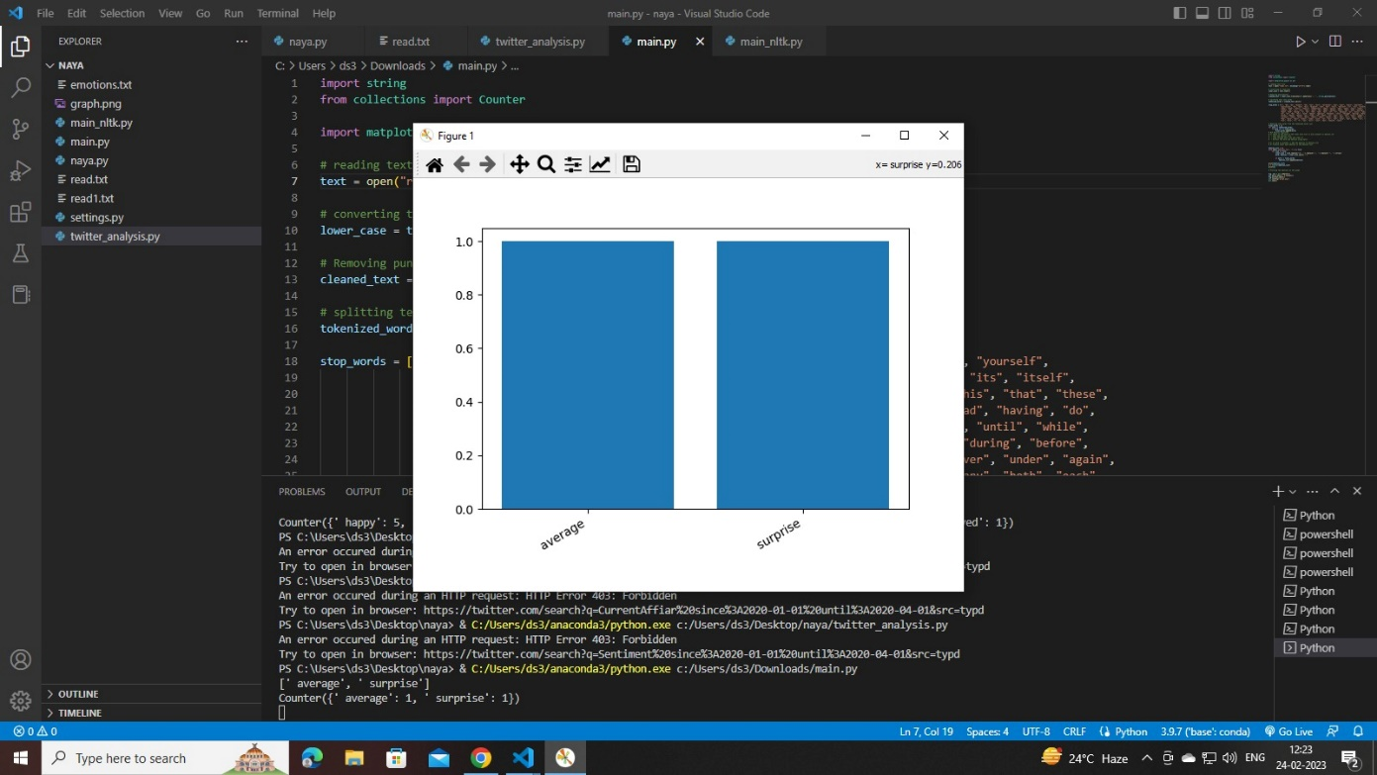

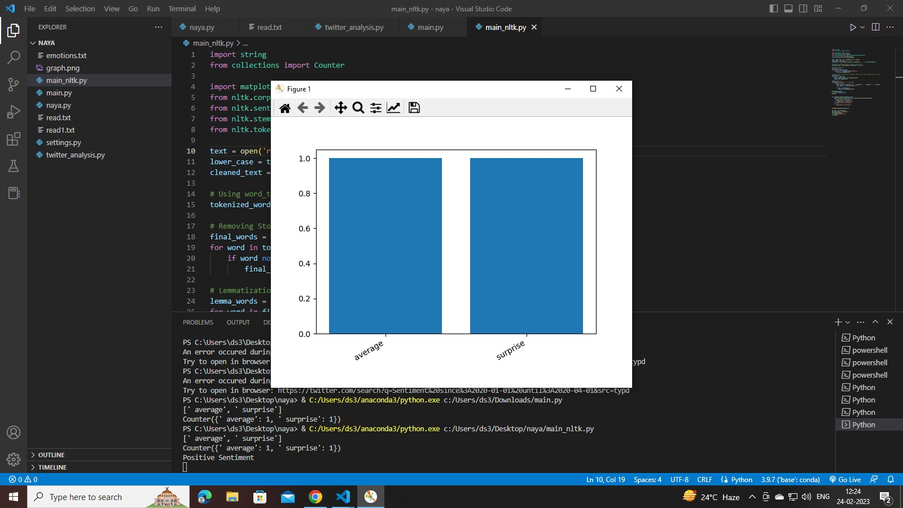

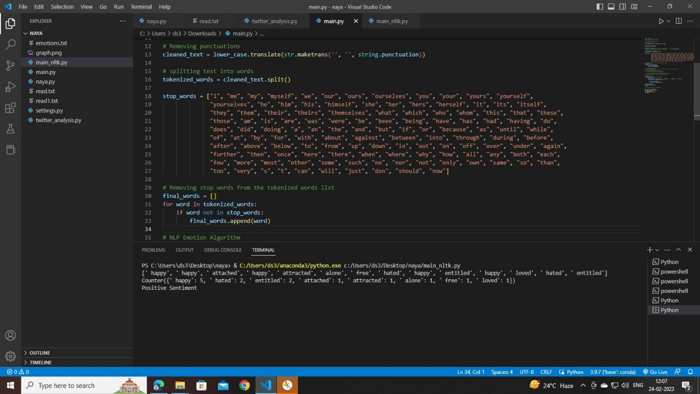

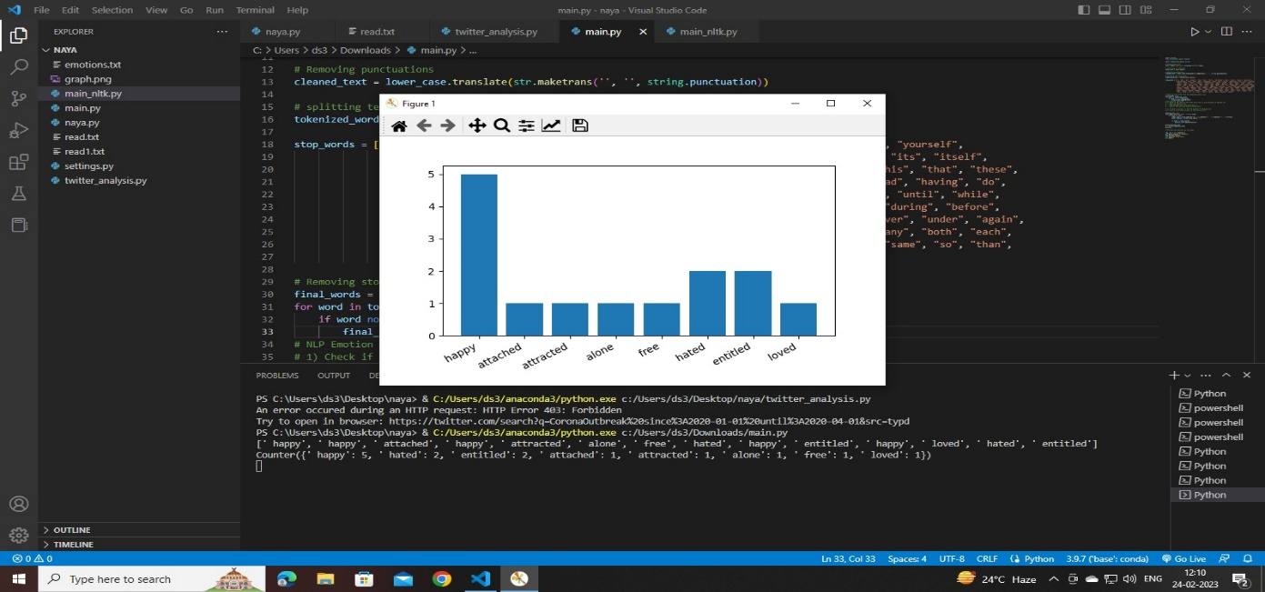

1. CONCLUSION :

In conclusion, it can be said that the capabilities of the WhatsApp application and the power of the python programming language in implementing whatever network data analysis intended, cannot be overemphasized. This work was able to discuss the WhatsApp application and its libraries, to create an analysis of a WhatsApp group chat and visually represent the top 10 and top 20 users in the chat groups. A pseudocode of the plot was given and at the end, visual representation of the plot was implemented. Also, an analysis of the top 10 and top 20 users were done. The system was done with python, and the python libraries that were implemented includes, NumPy, Pandas, Matplotlib and Seaborn. At the end of the work expected results were obtained and the analysis was able to show the level of participation of the various individuals on the given WhatsApp group. On serious note this system has the ability to analyze any WhatsApp group data input into it.

11.REFERENCES :

* + Availablefrom:http://www.statista.com/statistics/260819/num ber-of-monthly-active-WhatsApp-users.Number of monthly active WhatsApp users worldwide from April 2013 to February 2016(in millions).
  + D.Radha, R. Jayaparvathy, D. Yamini, Analysis on Social Media Addiction using Data Mining Technique, International Journal of Computer Applications (0975 8887) Volume 139 No.7, pp. 23- 26, April 2016.
  + Access Data Corporation. FTK Imager, 2013. Available at http://www.accessdata.com/support/product-downloads.